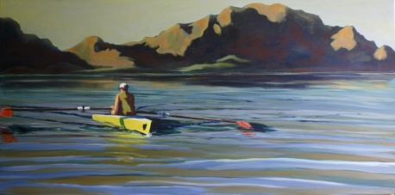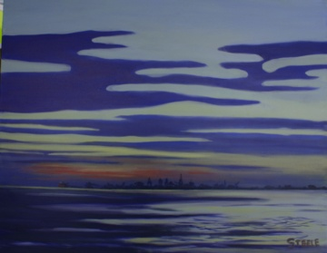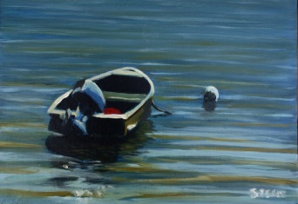
SCULLING COAL TERMINAL SUNSET SUMMER AFTERNOON
Acrylic on Canvas Acrylic on Canvas Acrylic on Canvas Board
48 in X 24 in 32 in X 28 in 15 in X 11 in
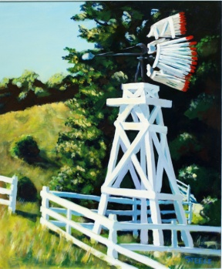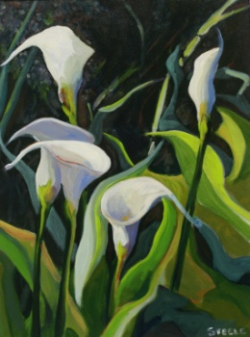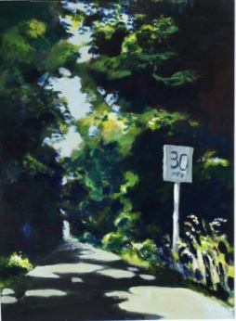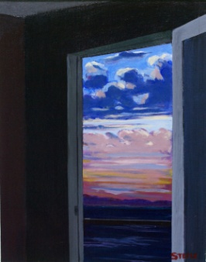
WIND POWER CALLE LILLIES A.P.A ROAD DAWN’S DOORWAY
Acrylic on Canvas Acrylic on Canvas Acrylic on Canvas Acrylic on Canvas Board
30 in X 36 in 17 in X 23 in 17 in X 23 in 15 in X 19 in

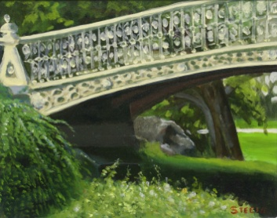 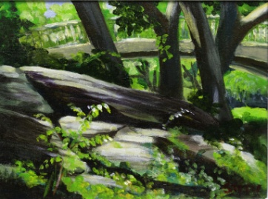 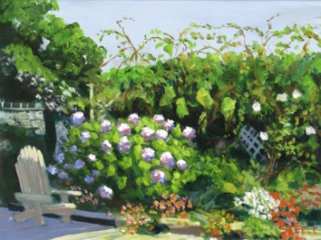 CENTRAL PARK BRIDGE CENTRAL PARK TREES PT BOB GARDEN
Acrylic on Canvas Acrylic on Canvas Board Acrylic on Canvas
19 in X 15 in 15 in X 11 in 23 in X 17 in

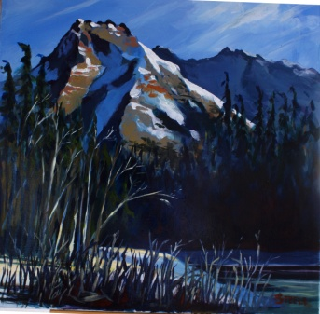 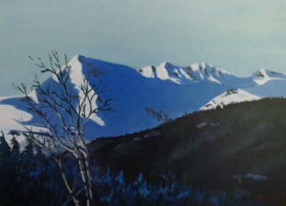 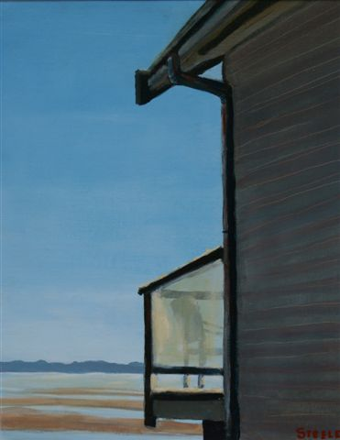 BOL DE ROCHE KISPIOX RANGE PT BOB MORNING
Acrylic on Canvas Acrylic on Canvas Board Acrylic on Canvas Board
36 in X 36 in 23 in X 17 in 15 in X 18 in

